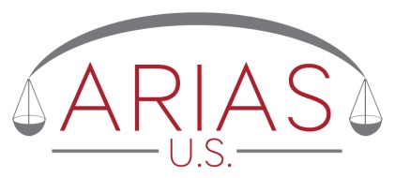
ARIAS•U.S. request form
Umpire/Neutral Panel Member Availability

To be put on law firm or Company Representative stationary

Attention: Executive Director, ARIAS•U.S.
_________________
(Date of this Request)

Dear Executive Director of ARIAS•U.S.:
We are the law firm/representatives of _________________________ (“the Requesting Company”). (Requesting Company name)

On behalf of the Requesting Company, we ask that you please contact the following ARIAS•U.S. certified arbitrator(s) to check their availability as we evaluate whether they should be asked to
[be a candidate for umpire] [sit as a neutral panel member] [select one].

- _________________________ (insert ARIAS•U.S. certified arbitrator name)

- _________________________ (insert ARIAS•U.S. certified arbitrator name)

- _________________________ (insert ARIAS•U.S. certified arbitrator name)
Without revealing the name of the Requesting Company or this firm/representative, please determine as to each of these individuals:
- Whether s/he is willing to take appointments as [umpire] [neutral arbitrator] in a (re)insurance dispute.
- Whether s/he is available to hold an in-person organizational meeting during the next ______ months. (insert number)

- Whether s/he is available to hold a ______ -day hearing during the next _____ (months).
(insert number) (insert number)

(If the Requesting Company has a date by which it would need to know availability, indicate that date: __________________________.)

We confirm that ARIAS•U.S. accepts no liability concerning this request and that ARIAS•U.S. is not required to retain this information for record-keeping purposes or otherwise. We, and the requesting company, waive all rights and remedies against ARIAS•U.S. for providing this free service.

We ask that ARIAS•U.S. not provide any indication of our firm/representative name, the name of the person who is making this request, or of the name of the company that we represent.

Thank you.

(Law Firm Signature and contact details)

