ARIAS•U.S. SAMPLE FORM 3.2: HOLD HARMLESS AGREEMENT
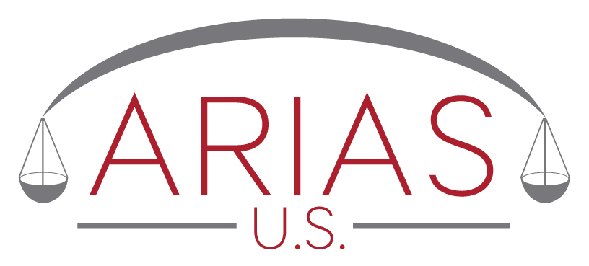

In the Matter of the Arbitration Between
_________________________________________
Petitioner,
- and -

._________________________________________
Respondent

STIPULATION

WHEREAS, (names of panel members) have been appointed to serve as members of the arbitration panel (“panel”) in the above-captioned arbitration; and

WHEREAS, an organizational meeting was held on __________________ (date) in _______________ (location), at which counsel for both parties and all members of the panel were present; and

WHEREAS, the panel members have, in good faith and to the best of their recollection, disclosed any interest in the outcome of these proceedings, and any business and social relationships which they have or have had among themselves and/or with parties, counsel, and, as applicable, others; and

WHEREAS, based on those disclosures, the parties have unanimously found that no panel member has any conflict of interest that would make him or her unfit to serve in this arbitration; and

WHEREAS, based on those disclosures, the parties accept this panel as being without conflicts of interest and duly constituted to hear the matter(s) under dispute in this arbitration.

NOW, THEREFORE, the parties agree as follows:

(1) Each party agrees that it shall not assert any claim, file any suit, or initiate any action against the panel or any member thereof in connection with their rendering of services as arbitrator and/or umpire in this arbitration proceeding (including, but not limited to, any claim, suit, or action relating to any alleged conflict, bias, or lack of disinterestedness); and

(2) Both parties further agree jointly and severally, to protect, defend, indemnify, and hold harmless any and all members of the panel against any and all expenses, costs, and fees of any kind incurred by the members of the panel, and the payment of their reasonable hourly fees, in connection with any claim, action, or lawsuit arising or resulting from or out of this arbitration.

Nothing in this stipulation, however, shall abridge any rights the Petitioner and Respondent may have with respect to each other to seek to vacate or modify any order, ruling, or award which the panel may render except in regard to any conflicts of interest that have been fully disclosed to the parties. This stipulation is non-cancelable and of unlimited duration.

Members of the panel:

Arbitrator: ___________________________

Arbitrator: ___________________________

Umpire: ___________________________

AGREED:

___________________________ for ________________________, Petitioner

___________________________ for ________________________, Respondent

Dated: _______________________

